Multiple-choice section – choose the correct answer

Question 1 [7.1]

For the triangle shown, which of the following represents the ratio  for the angle *a*?

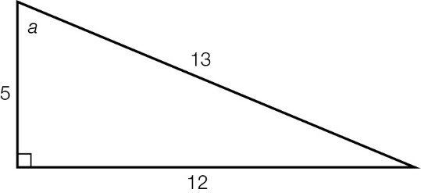

A B C D 

Question 2 [7.2]

If the sine ratio for the angle *a* = , the value of the unknown side *x* is:

**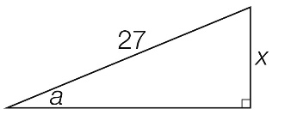**

A 3 B 9 C 15 D 27

Question 3 [7.3]

Which equation can be used to find the value of *k* in the diagram?

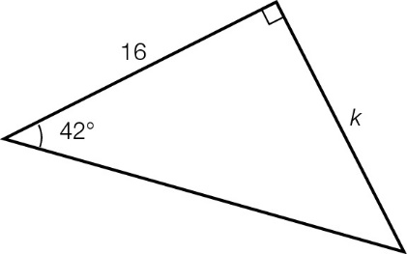

A sin(42°) =  B cos(42°) =  C tan(42°) =  D tan(42°) = 

Question 4 [7.5]

A 9.5 m tree casts a shadow across the ground. If the angle of elevation of the sun is 49°, the length of the shadow is closest to:

A 1.2 m B 6.2 m C 7.2 m D 8.3 m

Question 5 [7.5]

A bearing of 138°T, written as a compass bearing, is:

A N48°E **B** S48°E **C** S42°E **D** N42°W

Question 6 [7.4]

The value of θ in the diagram is equal to which of the following expressions?

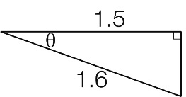

A  B  C  D 

Multiple-choice results: \_\_\_ / 6

Short answer section

Question 7 4 marks [7.3]

In an auditorium, a ramp is inclined at an angle of  from the ground to a stage at a height of 3.8 feet.

**(a)** Draw a diagram of the information provided.

**(b)** What is the length of the ramp to 1 decimal place?

Question 8 5 marks [7.5]

A bus travels 40 km on a bearing of N44°W.

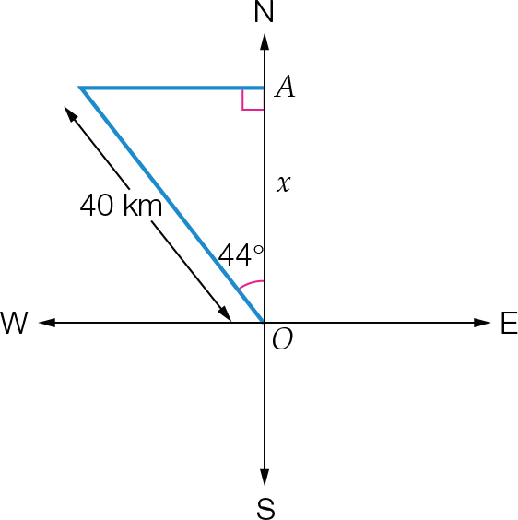

**(a)** How far north of its starting point is the bus?

**(b)** What is the true bearing equivalent to N44°W?

Question 9 5 marks [7.1]

A right-angled triangle has sides of length 7 cm, 24 cm and 25 cm.

**(a)** Draw a diagram of the triangle. Label the vertices *A*, *B* and *C*. Also label the right angle at *B* and the shortest side as *AB*. Mark the side lengths on the diagram, and label angle *ACB* as the reference angle θ.

**(b)** Label the sides O, A and H. Write the exact values for:

**(i)** sin(θ)

**(ii)** cos(θ)

**(iii)** tan(θ)

Question 10 6 marks [7.3]

Find the value of the unknown lengths, correct to 1 decimal place.

|  |  |  |
| --- | --- | --- |
| **(a)**  ACPM9_PR_7_09tf | **(b)**  ACPM9_PR_7_10tf | **(c)**  ACPM9_PR_7_09tsa_RR |

Question 11 6 marks [7.4]

Find the value of θ, correct to the nearest degree, in each of the following.

|  |  |  |
| --- | --- | --- |
| **(a)**  ACPM9_PR_7_11tf | **(b)**  ACPM9_PR_7_12tf | **(c)**  ACPM9_PR_7_12tsa |

Question 12 5 marks [7.2]

The adjacent side and hypotenuse of a triangle are 24 cm and 30 cm respectively.

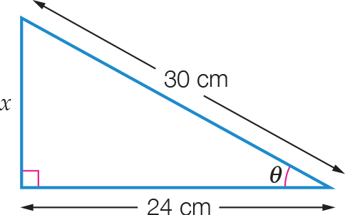

**(a)** Determine the opposite side in the triangle.

**(b)** Calculate the exact values of sin(θ), cos(θ) and tan(θ).

Question 13 3 marks [7.5]

The angle of elevation to the top of a mobile phone tower from a point 150 m from the base is 38°.

**(a)** Draw a diagram of the information provided.

**(b)** Find the height of the tower, correct to 1 decimal place.

Question 14 3 marks [7.3]

Find the perimeter of this semicircle, correct to 1 decimal place. Hint: The circumference of a circle can be found using *C* = 2π*r*.

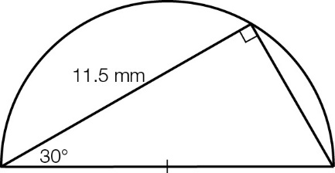

Short answer results: \_\_\_ / 37

Extended answer section

Question 15 7 marks [7.3, 7.4]

**(a)** The diagram below shows a section of a rectangular wall frame, constructed from wooden beams. Find the total length of wood needed for this section of the frame, correct to 2 decimal places.

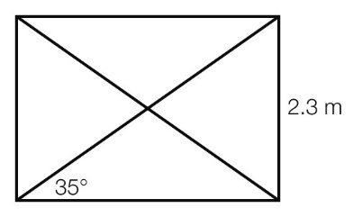

**(b)** The diagram below shows a triangular part of a roof frame. The ‘pitch angle’ θ is the angle that the sloping part of the roof makes with the horizontal. The frame is divided by a vertical beam into two symmetrical halves.

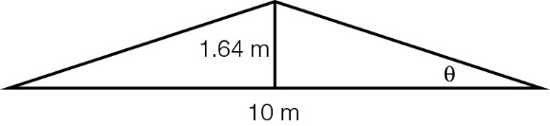

**(i)** Find the pitch angle θ correct to 1 decimal place.

**(ii)** Find the total length of wood needed to build the section of frame shown.

Question 16 6 marks [7.5]

**(a)** Ben is standing 38 m away from the base of a tower and observes that the angle of elevation to the top of the tower is 30°. Calculate the height of the tower correct to 2 decimal places.

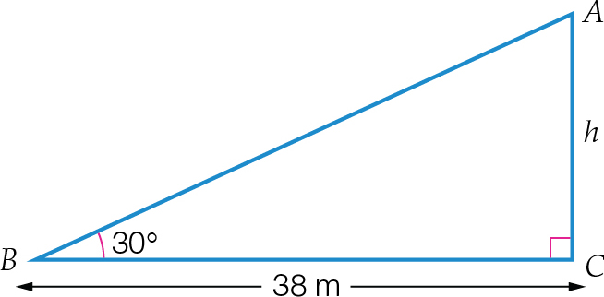

**(b)** What will be the angle of elevation, to the nearest degree, if he then moves 15 m towards the tower?

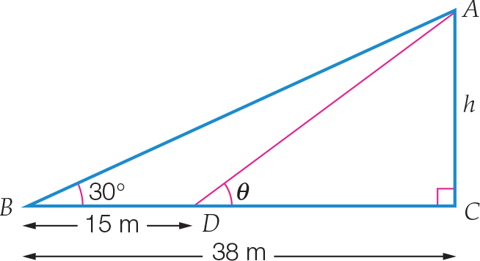

Extended answer results: \_\_\_ / 13

TOTAL test results: \_\_\_ / 56